EYFS Curriculum 2021

At Widden Primary School we follow the EYFS Framework. Within this framework there are four guiding principles which shape our practice.
These are:
- Every child is a unique child, who is constantly learning and can be resilient, capable, confident, and self-assured.
- Children learn to be strong and independent through positive relationships.
- Children learn and develop well in enabling environments with teaching and support from adults, who respond to their individual interests and needs and help them to build their learning over time. Children benefit from a strong partnership between practitioners and parents and/or carers.
Children develop and learn at different rates. The framework covers the education and care of all children in early years provision, including children with special education needs and disabilities.

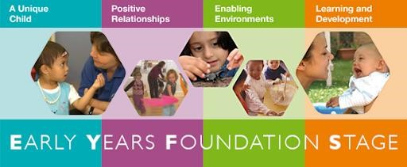

EYFS learning and development requirements
Our curriculum encompasses seven areas of learning and development. All areas of learning and development are important and inter-connected.
Three areas are particularly important for building a foundation for igniting children’s curiosity and enthusiasm for learning, forming relationships, and thriving.
These are called the prime areas:
- communication and language
- physical development
- personal, social, and emotional development.
Four areas help children to strengthen and apply the prime areas.
These are called the specific areas:
- literacy
- mathematics
● understanding the world
- expressive arts and design

Throughout their time in the Nursery and Reception our children partake in an ambitious curriculum which is designed in a sequential way to ensure progress towards the end of Reception goals. These goals are defined as Early Learning Goals (ELGs). The descriptors for these can be found in the appendix.
As previously outlined our curriculum incorporates learning through play, learning by adults modelling, by observing each other and through guided learning and direct teaching. It is also important to highlight that our plans are flexible to allow us to respond quickly to children’s new interests and/or needs.
Weaving throughout the EYFS curriculum at Irby Primary are three Characteristics of Effective Learning.
  - playing and exploring - children investigate and experience things, and ‘have a go’
  - active learning - children concentrate and keep on trying if they encounter difficulties, and enjoy achievements
  - creating and thinking critically - children have and develop their own ideas, make links between ideas, and develop strategies for doing things

The Early Learning Goal Descriptors
  Communication and Language
  ELG: Listening, Attention and Understanding
  - Listen attentively and respond to what they hear with relevant questions, comments and actions when being read to and during whole class discussions and small group interactions.
  - Make comments about what they have heard and ask questions to clarify their understanding.
  - Hold conversation when engaged in back-and-forth exchanges with their teacher and peers.
  ELG: Speaking
  - Participate in small group, class and one-to-one discussions, offering their own ideas, using recently introduced vocabulary.
  - Offer explanations for why things might happen, making use of recently introduced vocabulary from stories, non-fiction, rhymes, and poems when appropriate.
  -Express their ideas and feelings about their experiences using full sentences, including use of past, present and future tenses and making use of conjunctions, with modelling and support from their teacher.
  Personal, Social and Emotional Development
  ELG: Self-Regulation
  - Show an understanding of their own feelings and those of others and begin to regulate their behaviour accordingly.
  - Set and work towards simple goals, being able to wait for what they want and control their immediate impulses when appropriate.
  - Give focused attention to what the teacher says, responding appropriately even when engaged in activity, and show an ability to follow instructions involving several ideas or actions.
  ELG: Managing Self
  - Be confident to try new activities and show independence, resilience, and perseverance in the face of challenge.
  - Explain the reasons for rules, know right from wrong and try to behave accordingly.
  - Manage their own basic hygiene and personal needs, including dressing, going to the toilet, and understanding the importance of healthy food choices.
  ELG: Building Relationships
  - Work and play cooperatively and take turns with others.
  - Form positive attachments to adults and friendships with peers.
  - Show sensitivity to their own and to others’ needs.
  Physical Development
  ELG: Gross Motor Skills
  - Negotiate space and obstacles safely, with consideration for themselves and others.
  - Demonstrate strength, balance and coordination when playing; Move energetically, such as running, jumping, dancing, hopping, skipping, and climbing.
  ELG: Fine Motor Skills
  Children at the expected level of development will:
  - Hold a pencil effectively in preparation for fluent writing – using the tripod grip in almost all cases.
  - Use a range of small tools, including scissors, paint brushes and cutlery.
  - Begin to show accuracy and care when drawing.
 |  | 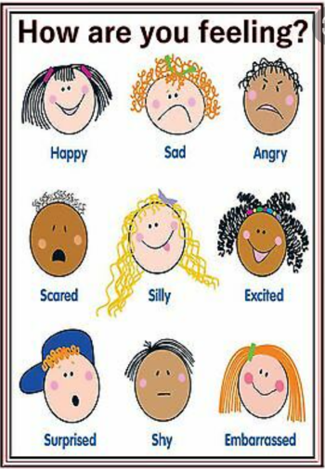

Understanding the World  ELG: Past and Present  - Talk about the lives of the people around them and their roles in society.  - Know some similarities and differences between things in the past and now, drawing on their experiences and what has been read in class.  - Understand the past through settings, characters and events encountered in books read in class and storytelling.  ELG: People, Culture and Communities  - Describe their immediate environment using knowledge from observation, discussion, stories, non-fiction texts and maps.  - Know some similarities and differences between different religious and cultural communities in this country, drawing on their experiences and what has been read in class.  - Explain some similarities and differences between life in this country and life in other countries, drawing on knowledge from stories, non-fiction texts and when appropriate maps.  ELG: The Natural World  - Explore the natural world around them, making observations and drawing pictures of animals & plants.  - Know some similarities and differences between the natural world around them and contrasting environments, drawing on their experiences and what has been read in class.  - Understand some important processes and changes in the natural world around them, including the seasons and changing states of matter. |  | Expressive Arts and Design  ELG: Creating with Materials  - Safely use and explore a variety of materials, tools, and techniques, experimenting with colour, design, texture, form and function.  - Share their creations, explaining the process they have used.  - Make use of props and materials when role playing characters in narratives and stories.  ELG: Being Imaginative and Expressive  - Invent, adapt, and recount narratives and stories with peers and their teacher.  - Sing a range of well-known nursery rhymes and songs; Perform songs, rhymes, poems, and stories with others, and – when appropriate – try to move in time with music.
Mathematics
ELG: Number
- Have a deep understanding of number to 10, including the composition of each number;
- Subitise (recognise quantities without counting) up to 5;
- Automatically recall (without reference to rhymes, counting or other aids), number bonds up to 10 (including subtraction facts) and some number bonds to 10, including double facts.

ELG: Numerical Patterns
- Verbally count beyond 20, recognising the pattern of the counting system;
- Compare quantities up to 10 in different contexts, recognising when one quantity is greater than, less than or the same as the other quantity;
- Explore and represent patterns within numbers up to 10, including evens and odds, double facts and how quantities can be distrusted equally
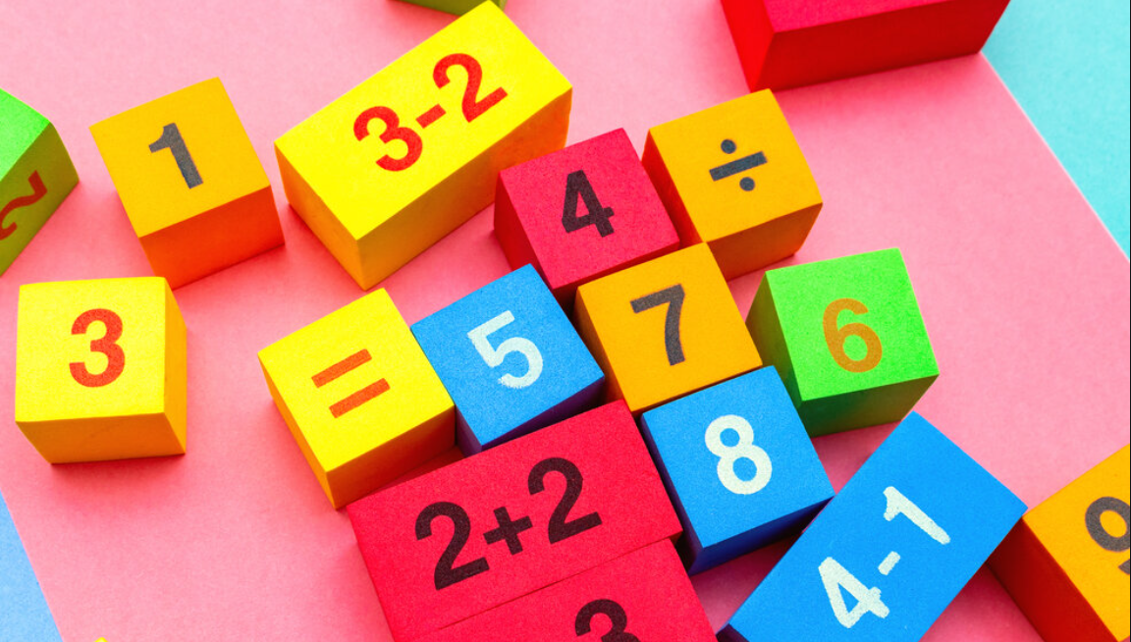
Literacy
ELG: Comprehension
- Demonstrate understanding of what has been read to them by retelling stories and narratives using their own words and recently introduced vocabulary:
- Anticipate – where appropriate – key events in stories;
- Use and understand recently introduced vocabulary during discussions about stories, non-fiction, rhymes and poems and during role-play.
ELG: Word Reading
- Say a sound for each letter in the alphabet and at least 10 digraphs;
- Read words consistent with their phonic knowledge by sound-blending;
- Read aloud simple sentences and books that are consistent with their phonic knowledge, including some common exception words.
ELG: Writing
- Write recognisable letters, most of which are correctly formed;
- Spell words by identifying sounds in them and representing the sounds with a letter or letters;
- Write simple phrases and sentences that can be read by others.

